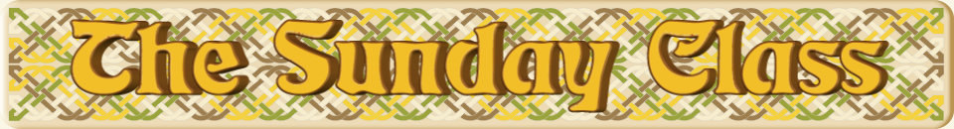

Sunday 26th February 2017 at Castle Bytham Village Hall
4.00pm - 7.00pm

The Bees They Are a’Drummin’ (R8x32)

Father Connelly’s Jig (J4x64)

The Orchards of County Armagh (S3x32)

Zytglogge (R8x32)

Lady in Red (J5x32)

The Flower o’ the Quern (S4x32)

Interval – Tea and cakes!

Anniversary Tensome (R5x52)

Giradet House (S4x32)

Broadford Bay (R8x32)

Rougemont Castle (S3x32)

The Sour Lemon (J8x40)

The Recumbent Stone (R5x48)

- - - - - - - - - - - -

www.thesundayclass.org.uk

